CSA1023 – SOFTWARE ENGINEERING

Question 4

Create a Scrum Project in Jira.

• Add a backlog with at least 5 items (e.g., "Create user registration page", "Develop API for login").

• Prioritize the backlog and create a 1-week sprint.

• Move backlog items into the sprint and start the sprint.

• Finally show the Screenshot of the sprint board at the start and end of the sprint

**Add Backlog Items**

1. Navigate to your project dashboard.
2. Click on **Backlog** from the left menu.
3. Click **Create Issue** and add at least five backlog items.
   * Example items:
     + **Create user registration page**
     + **Develop API for login**
     + **Design database schema**
     + **Implement password reset functionality**
     + **Write unit tests for authentication module**
4. Press **Enter** after adding each item.

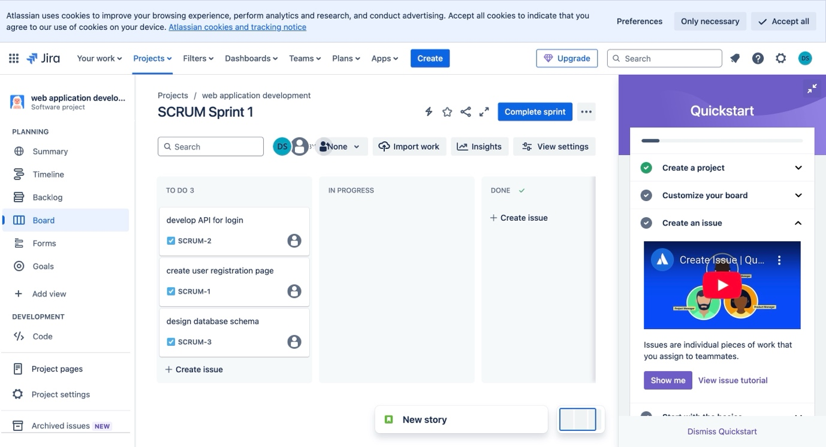

**Prioritize the Backlog**

1. Drag and drop backlog items to rearrange them based on priority.
2. Place the most critical tasks at the top.

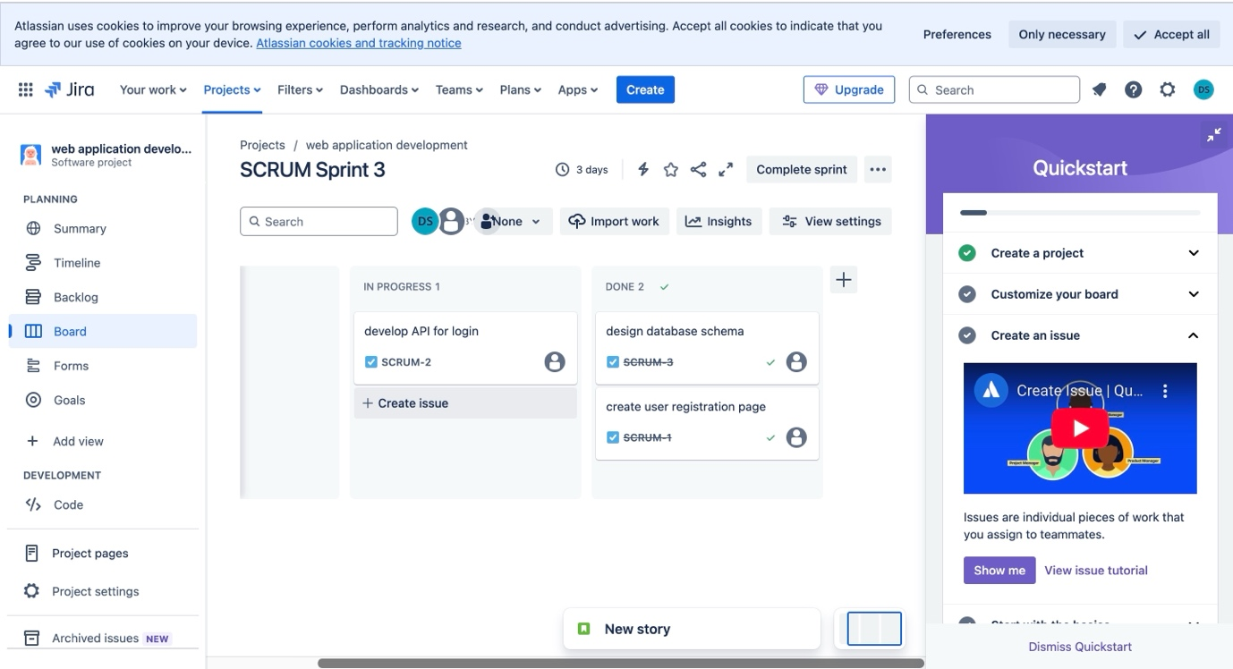

**Create and Start a Sprint**

1. Click on the **Backlog** tab.
2. Click **Create Sprint**.
3. Drag backlog items into the **Sprint** section.
4. Click **Start Sprint**.
5. Set the sprint duration to **1 week**.
6. Give the sprint a name (e.g., **Sprint 1 - User Authentication**).
7. Set the start and end date.
8. Click **Start**.

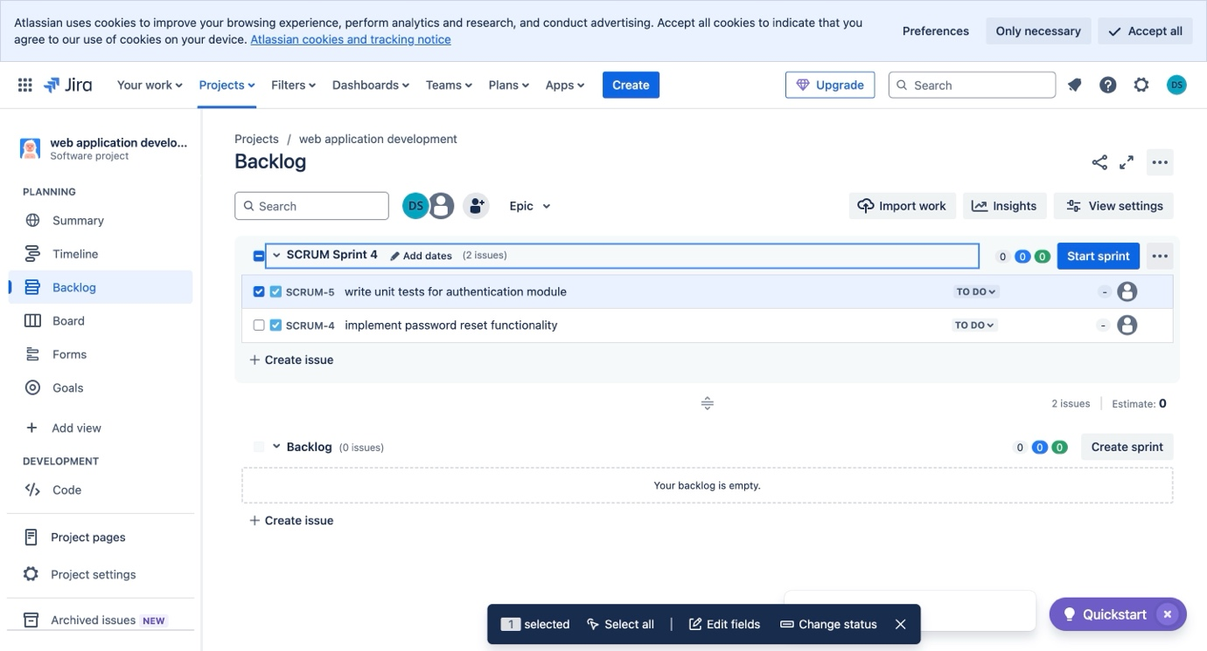

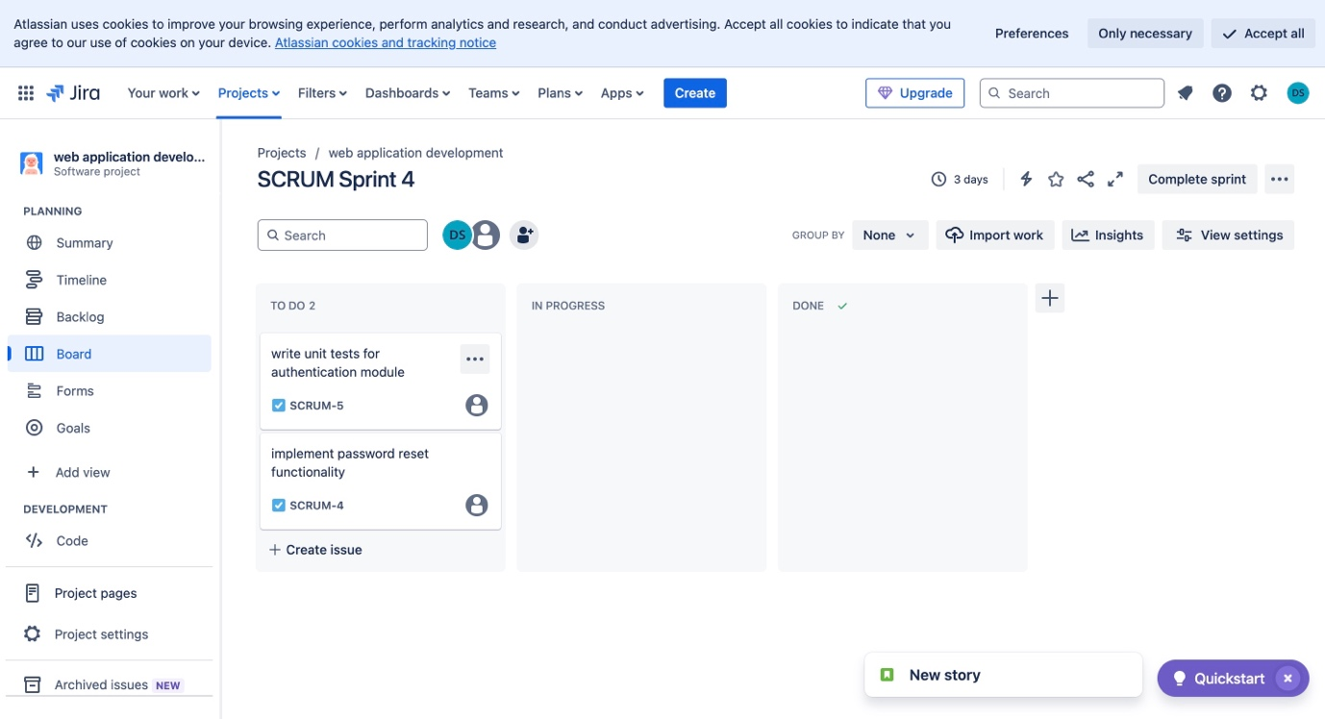

**Move Tasks on the Sprint Board**

1. Click on **Active Sprint** from the left menu.
2. Drag tasks from **To Do** → **In Progress** → **Done** as you work on them.

